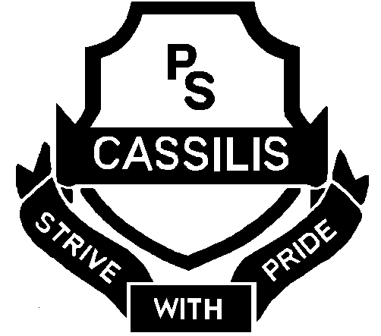

CASSILIS PUBLIC SCHOOL

Coolah Road Ph: (02) 63761009
CASSILIS 2329 Fax: (02) 63761005
Email address: cassilis-p.school@det.nsw.edu.au

20 November 2014

Dear Parents / Caregivers

Due to our Mini Fair being held next Tuesday lunch orders from the General Store will not be available. Hot dogs will be available for purchase from the Mini Fair.

With the end of Term almost here there will be no more borrowing from the Library. Parents will need to pay for the books that have not been returned to the Library. Notes will be sent home on the 5 December for any books that have not been returned prior to this date.

Please be reminded that students are to be collected from the Cassilis Library at 3:00pm on Friday 21 November 2014.

Please do not hesitate to contact me should you require any further information.

Yours sincerely
Jeanette Grinham
RELIEVING PRINCIPAL

CASSILIS PUBLIC SCHOOL

Coolah Road Ph: (02) 63761009
CASSILIS 2329 Fax: (02) 63761005
Email address: cassilis-p.school@det.nsw.edu.au

20 November 2014

Dear Parents / Caregivers

Due to our Mini Fair being held next Tuesday lunch orders from the General Store will not be available. Hot dogs will be available for purchase from the Mini Fair.

With the end of Term almost here there will be no more borrowing from the Library. Parents will need to pay for the books that have not been returned to the Library. Notes will be sent home on the 5 December for any books that have not been returned prior to this date.

Please be reminded that students are to be collected from the Cassilis Library at 3:00pm on Friday 21 November 2014.

Please do not hesitate to contact me should you require any further information.

Yours sincerely
Jeanette Grinham
RELIEVING PRINCIPAL

