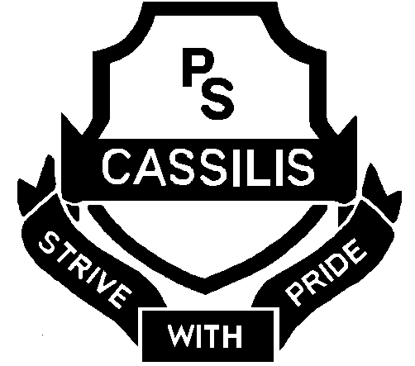

CASSILIS PUBLIC SCHOOL

Coolah Road Ph: (02) 63761009
CASSILIS 2329 Fax: (02) 63761005
Mob: 0428647636
Email address: cassilis-p.school@det.nsw.edu.au

School Photo Re-shoot
As the P&C were unhappy with some school photos, all photos will be redone on Friday 21st November by a different photographer.
Please send your students to school in a clean, full school uniform – including black school shoes and school coloured ribbons. Relay and Touch football teams will need to bring their sport shirts for team photos.
If you would like sibling photos please let the office know.
You will be able to bring in a USB stick to obtain free copies of all photos that include your child/ children that can then be printed as you wish.
Thank you for your cooperation in this matter.

Jeanette Grinham
Relieving Principal

CASSILIS PUBLIC SCHOOL

Coolah Road Ph: (02) 63761009
CASSILIS 2329 Fax: (02) 63761005
0428647636
Email address: cassilis-p.school@det.nsw.edu.au

School Photo Re-shoot
As the P&C were unhappy with some school photos, all photos will be redone on Friday 21st November by a different photographer.
Please send your students to school in a clean, full school uniform – including black school shoes and school coloured ribbons. Relay and Touch football teams will need to bring their sport shirts for team photos.
If you would like sibling photos please let the office know.
You will be able to bring in a USB stick to obtain free copies of all photos that include your child/ children that can then be printed as you wish.
Thank you for your cooperation in this matter.

Jeanette Grinham
Relieving Principal

