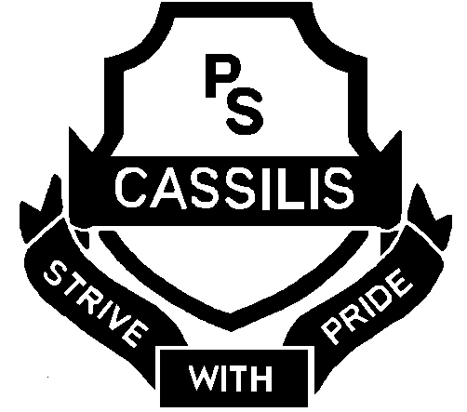

CASSILIS PUBLIC SCHOOL

Coolah Road Ph: (02) 63761009
CASSILIS 2329 Fax: (02) 63761005
Email address: cassilis-p.school@det.nsw.edu.au

19 November 2014

Dear Parents / Caregivers

As you are aware the Year 6 students will be holding a Mini Fair Fundraiser on Tuesday 25 November 2014 on school grounds between 11:00am and 1:00pm.

We are asking for support from all of our school families (not only Year 6). Some suggestions on ways to show your support for the Mini Fair are contributing to the Cake stall by cooking cakes, slices, biscuits, sweets etc. It is a requirement that all homemade food sold on any stalls are labelled with the ingredients. We will also be holding a white elephant stall, so any high quality donations will be gladly accepted.

To make the day a success we need people to come along. Please join us on the day and bring family and friends with you to join in the fun.

Regards
Jeanette Grinham
RELIEVING PRINCIPAL

CASSILIS PUBLIC SCHOOL

Coolah Road Ph: (02) 63761009
CASSILIS 2329 Fax: (02) 63761005
Email address: cassilis-p.school@det.nsw.edu.au

19 November 2014

Dear Parents / Caregivers

As you are aware the Year 6 students will be holding a Mini Fair Fundraiser on Tuesday 25 November 2014 on school grounds between 11:00am and 1:00pm.

We are asking for support from all of our school families (not only Year 6). Some suggestions on ways to show your support for the Mini Fair are contributing to the Cake stall by cooking cakes, slices, biscuits, sweets etc. It is a requirement that all homemade food sold on any stalls are labelled with the ingredients. We will also be holding a white elephant stall, so any high quality donations will be gladly accepted.

To make the day a success we need people to come along. Please join us on the day and bring family and friends with you to join in the fun.

Regards
Jeanette Grinham
RELIEVING PRINCIPAL

